STEPS TO INSTALL THE HIGH-SPEED FUNDRAISING FITNESS TEST

- Click link on website
- Click download ARROW beside ZIPPED file name
- Click OPEN file
- DOUBLE-CLICK FFT.EXT file
- In pop-up box, click EXTRACT ALL
- In password pop-up box type Fitness23!, then click OK
- DOUBLE-CLICK FITNESSTESTTEMPLATE.EXE
- In pop-up box click EXTRACT ALL
- In pop-up box click EXTRACT
- In DOWNLOADS folder DOUBLE-CLICK FFT.EXE file with red square with white line-graph
- In PROTECTED pop-up box click MORE INFO, then click RUN ANYWAY
- In SETUP FFT pop-up box click NEXT 3 TIMES, then click INSTALL, then click FINISH

THIS IS WHAT THE HIGH -SPEED FUNDRAISING FITNESS TEST INPUT SCREEN LOOKS LIKE 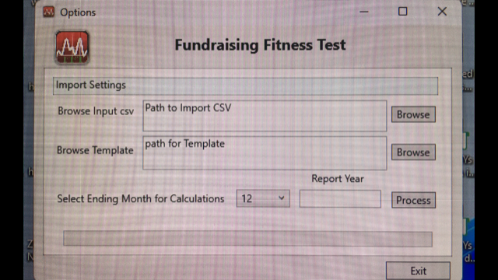

STEPS TO RUN THE FUNDRAISING FITNESS TEST REPORTS

- In FUNDRAISING FITNESS TEST 1st BROWSE window, DOUBLE-CLICK on your 3 column export file
- In FUNDRAISING FITNESS TEST 2nd BROWSE window DOUBLE-CLICK TEMPLATE.XLSM
- Set ENDIING month by selecting NUMBER of corresponding month from dropdown menu
- TYPE 4-digit YEAR for END POINT of reports, then click PROCESS
- TYPE name of report, then click SAVE
- Click the < at the bottom-left corner of the window several times until TOP INDICATORS is visible
- Click on TOP INDICATORS worksheet and RE-SAVE the file so it opens to 1st report automatically
*The TOP INDICATORS are performance indicators that will show improvement the next time
you run the Fundraising Fitness Test, depending on how you invest your staff time and budget
EXPORT TIPS
What to Export:
All cash gifts & pledge payments (exclude unpaid pledges & in-kind gifts that are not converted to cash).
Include 7 years of data to fully populate the trends report.

Fields and Format for Export:
The Donor ID# (to link multiple gifts), Date & Amount of each gift.
If a Header Row (Column Titles) is exported, this row must be deleted before this program can process the reports.
If file is not exported as a CSV it must be re-saved as a CSV for this program to process it (this also eliminates formatting codes).

Raiser’s Edge Gift Transaction Data Export Steps:
1) Create a gift query with GIFT DATE OPERATOR“ Greater Than or Equal to” and then specify the starting date
2) Use the “and” to choose cash as gift type, and specify GIFT AMOUNT greater than or equal to $0.
3) On the output tab, select CONSTITUENT ID NUMBER, GIFT DATE and GIFT AMOUNT.
4) Run Query
5) Export to Excel (as a CSV if possible)

eTapestry Gift Transaction Data Export Steps:
1) For Data Return Type, select JOURNAL ENTRIES.
2) For Starting Criteria: for Category, select BASE, and for Query, select ALL Constituents.
3) For Criteria, under Available Fields, select COMMONLY USED FIELDS from the drop-down menu. Choose INDIVIDUAL TRANSACTION RECEIVED.
4) For Individual Transaction Received, set the parameters to GREATER THAN OR EQUAL TO $1.00.

